

**How to Host a Mapathon**

Table of Contents

Missing Maps Summary ..........................................................................................................3

The Mapping Process ...............................................................................................................4

Ingredients for a Successful Mapathon .............................................................................5

Planning a Mapathon ...............................................................................................................6

1. Planning Checklist ………………..…………………………………………………….……………6

2. Event Day Checklist ........................................................................................................7

3. Post-Mapathon Wrap Up …....………............................................................................7

4. How the Missing Maps Team Can Help...................................................................8

5. Mapping Resources………………………………………………………………………….………9

Missing Maps Summary

Recent disaster trends indicate that people are increasingly impacted by more frequent and severe disasters, particularly in vulnerable communities around the world. Urbanization has made matters worse; more than half the world’s population currently lives in cities often located on coastlines and fault lines. These cities frequently lack sufficient infrastructure to support the informal settlements that have sprung up within them. One billion people – 1/7th of the world’s population – now live in urban slums (United Nations Development Report). Overcrowding, poorly-built dwellings, and insufficient infrastructure has left hundreds of millions of people increasingly vulnerable to disaster and disease.

A first step to assisting these communities is to ensure that we know where they are. The Missing Maps Project is an unprecedented collaboration between the American Red Cross, British Red Cross, Médecins Sans Frontières-UK (MSF-UK or Doctors Without Borders-UK) and the Humanitarian OpenStreetMap Team to map the world’s most vulnerable communities.

The Missing Maps Project has begun mapping locations where partner organizations are already conducting disaster preparedness and risk reduction activities. As major disasters strike, affected communities may also be prioritized.

Digital volunteer engagement is vital for the success of many humanitarian organizations around the world responding to disasters. It is imperative to have a larger pool of trained volunteers that are ready to assist with little coordination when a disaster occurs.

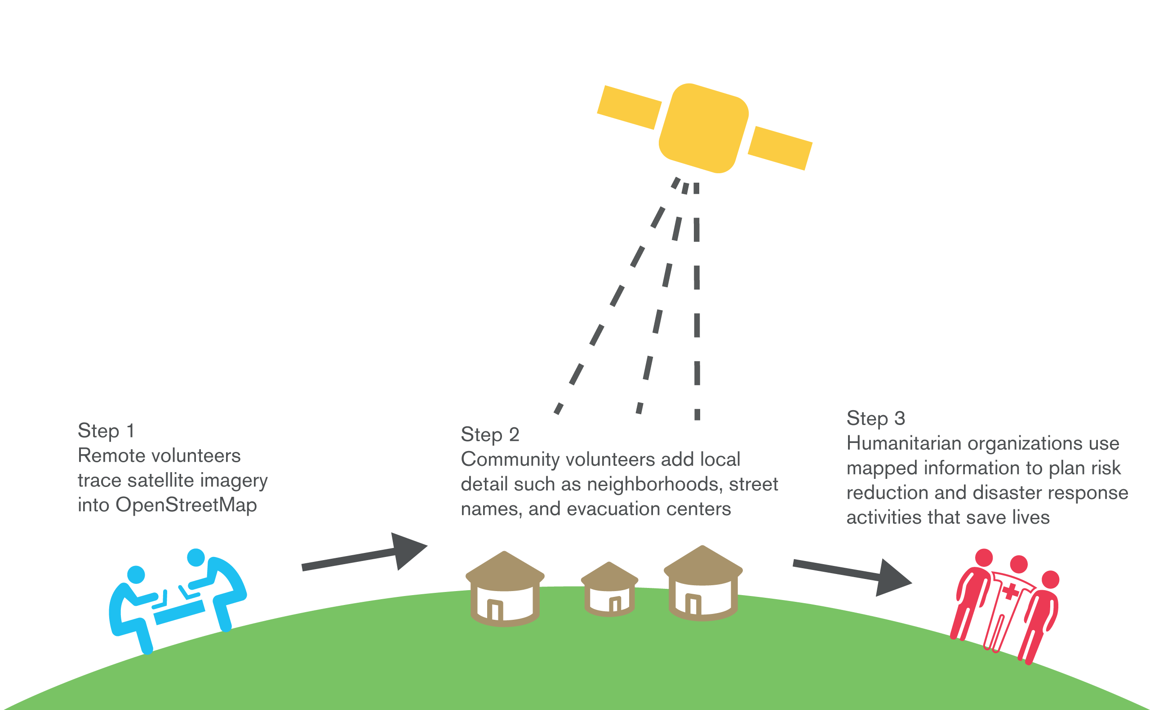**The Mapping Process**

Ingredients for a Successful Mapathon

Mapathons are an engaging and cutting-edge opportunity designed to help deepen a volunteers’ relationship with the Missing Maps project. The objective of a mapathon is to engage volunteers to digitally map the most vulnerable places in the developing world so that local and international NGOs can use these comprehensive maps and data to better respond to crises affecting these areas.

B**asic Ingredients for a Successful Mapathon:**

* Participants
* A space that fits your group
* Computers for every participant
* Mice or styluses
* Attendance log
* Enthusiasm

Useful Additional Ingredients**:**

* Extra laptops/computers for people that may not bring their own
* Extra mice
* Registration table
* Printed training materials
* Snacks or lunch (we suggest pizza!)

Planning the Mapathon

Hosting a mapathon is relatively simple, and requires no special skills or previous mapping experience! Planning for a mapathon typically requires several weeks of advance notice in order to coordinate and prepare for the event.

The following sections will outline the steps for planning:

1. Planning Checklist
2. Event Day Checklist
3. Post-Mapathon Wrap Up
4. How the Missing Maps Team Can Help
5. Mapping Resources

**1. Planning Checklist**

* Set a date and time for the mapathon. We suggest blocking off 2 hours, which will include:
  + 5-minutes to welcome people to the room and ask them to sign into or sign up for their accounts
  + 5-minute welcome presentation
  + 10-minute presentation on Missing Maps
  + 10-minutes of mapping training
  + 15-minutes to get comfortable with a new skill
  + 70-minutes to map comfortably
  + 5-minutes to wrap-up and log volunteer hours
* Reserve a space that can comfortably hold your participants and their equipment. If you would like to have a registration table, don’t forget to account for that.
* Recruit helpers. They can help with presentations, trainings, troubleshooting, registration, food/drinks, and photography.
* Create and distribute an invite. Remind mappers to bring their own laptops and mouse or stylus.
* If desired, arrange refreshments for the mappers.
* Choose a task for your group to map using the [Partner Page](http://www.missingmaps.org/partners/microsoft/).
* Identify a group hashtag to track your groups impact during the event.
* Download and review mapathon resources <link>. Please feel free to make these your own, keeping in mind the logo usage guidelines <link>.
* Print mapathon materials including step-by-step mapping guide <link> and project number and hashtag handout <link>.
* If desired, create an attendance sheet for your participants.
* Make a playlist of music from the country you will be mapping to play at the event. This one is optional but very enjoyable!
* One week out, remind participates of the event and ask them to create an account on OpenStreetMap (OSM).
* Practice mapping and get excited!

**2. Event Day Checklist**

* Set up the room by putting out paper resources, and snacks. Put the attendance sheet near the entrance. Set up the registration table, if you have one.
* Check on your mapping task to ensure there is enough work for your group. Pick a new task if needed and update your print materials.
* If you are reusing a hashtag that was used for a previous event, make sure to note the current progress on the hashtag before your groups starts mapping. You will refer to this later to determine what was accomplished during the new event.
* Cue up Missing Maps overview deck <link> and test demo links to ensure everything is working correctly.
* Have fun mapping!

**3. Post-Mapathon Wrap Up**

* If you used a unique hashtag, check the [leaderboard](http://www.missingmaps.org/leaderboards/#/missingmaps) for your group’s contribution totals.
* Follow up and thank your participants using this post event email template <link>. Don’t forget to let them know about your group’s contribution totals and any upcoming Mapathons.
* Start planning your next event!

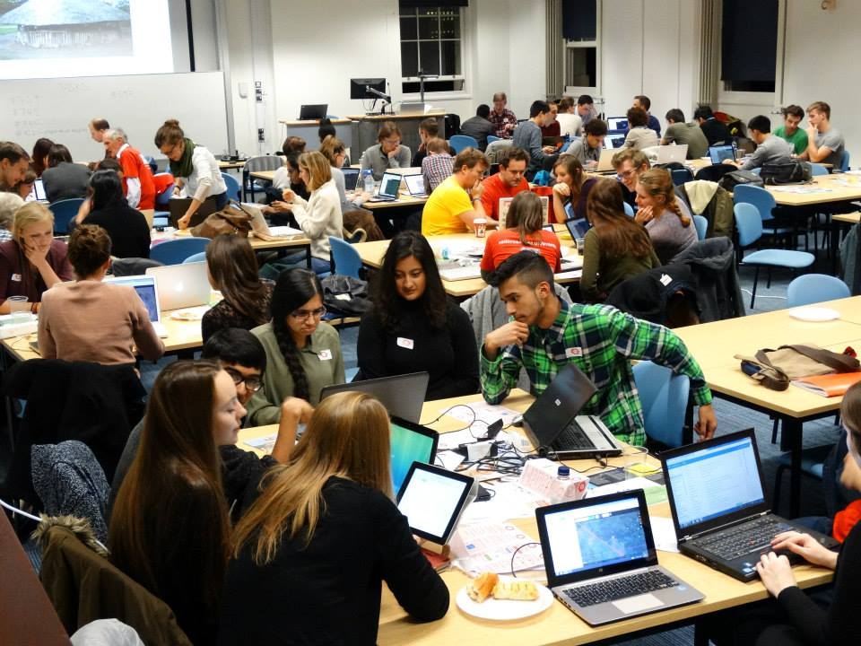

**4. How the Missing Maps Team Can Help**

The Missing Maps team can support you in several ways.   Please reach out to [Colin Peterson](mailto:colin.peterson@redcross.org) and/or [Morgan Beach](mailto:morgan.beach@redcross.org) for help with event facilitation or mapping questions.

**5. Mapping Resources**

**Why Map?**

* Missing Maps Website:  
  http://www.missingmaps.org
* Humanitarian Remote Mapping Introductory Video:  
  http://www.youtube.com/watch?v=C175zW8-6j8

**Learn to Map:**

* MapGive Resources for new Mappers:  
  http://mapgive.state.gov/learn-to-map/
* OpenStreetMap Resources for new Mappers:  
  http://learnosm.org
* Wiki: How to label or “tag” mapped features: http://wiki.openstreetmap.org/wiki/Map_Features

**Get started Mapping:**

* Tasking Manager:   
  http://tasks.hotosm.org
* OpenStreetMap (OSM):   
  http://osm.org
* Live OpenStreetMap Mapping - for display purposes:  
  http://osmlab.github.io/show-me-the-way/

**Donate and Volunteer:**

* Contribute to Missing Maps:  
  http://www.missingmaps.org#contribute